Patient Intake Form
Full Name: Date:
First MI Last

Address: City: State: Zip:

Age: Date of Birth (DOB): Gender:

Social Security Number: Email Address:

Home Phone: Work Phone: Cell/Other:

Employer: Occupation:

Preferred Language: (Circle One) English / Spanish / French / Other:

Race: (Circle One) American Indian or Alaska Native / Asian / Black or African American / White or Caucasian /
Hispanic or Latina / Native Hawaiian or Pacific Islander / Other / Decline to Answer
Current marital status: Single / Married / Separated / Divorced / Widowed / Minor

Insurance Information
Policy Holder / Relationship to Patient: Policy Holder’s Date of Birth:

Emergency Contact / Relationship to Patient:

Emergency Contact Phone Number:

Do you use tobacco products? □ Yes □ No packs / cans per . How many years?
Do you drink alcoholic beverages? □ Yes □ No drinks per day.
Do you exercise? □ Yes □ No Hours/ week? Activities?
For women: Are you pregnant or nursing? □ Yes □ No If pregnant, How many weeks?

Allergies (Medications, foods, animals, …etc) and reaction:

Current Medication/Supplement List:
Name / Condition Treated | Dose / Frequency | Name / Condition Treated | Dose / Frequency
Family History (list all major diseases (such as cancer, diabetes, heart problems, bone/joint diseases) of blood relatives, the
Individuals relation to you, and whether they are alive or deceased):

Past Medical Procedures / Surgeries:
Procedure | Date (Month and Year) | Procedure | Date (Month and Year)

Describe the reason(s) for your doctor visit today:

Are you here because of an accident? What type?
When did your symptoms start? _________________________________ How did your symptoms begin? ______________________
___________________________________________________________________________________________________________________________________
How often do you experience symptoms? (Circle one) Constantly Frequently Occasionally Intermittently
Are your symptoms? (Circle one) Getting better Staying the same Getting worse
How do your symptoms interfere with your work or normal activities?

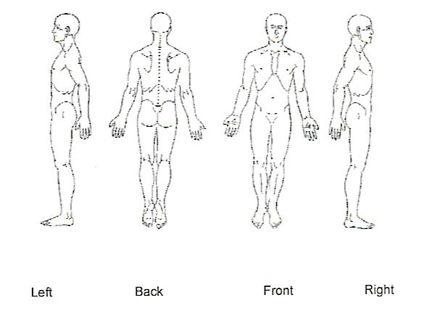
On a scale of 1-10, please circle how intense your symptoms are: Not intense Unbearable
Mark any area(s) of discomfort with the following key:
A =Ache N =Numbness B = Burning
T = Tingling S = Stiffness O = Other

For the conditions above, please indicate if you have had the
condition in the past or if you presently have the condition.
Name and Clinic of Previous Chiropractor: Date of last treatment:
Have you seen another doctor for these symptoms? If yes, indicate name and type of medical provider:

Primary Care Physician/Clinic:

Address: Phone: Date last seen:

